(Approx. 489 words)

Stellarium
By Cal Esneault, President of the Cajun Clickers Computer Club, LA and leader of many Open Source Workshops & SIGs
December 2011 issue, Cajun Clickers Computer News
http://cccclinuxsig.pbwiki.com
www.clickers.org
ccnewsletter (at) cox.net

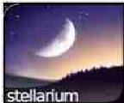
In my youth, I would take a copy of my uncle’s Star and Telescope magazine and go to the center section to use the two-page star map guide. Twisting and turning the map to match my view, the many constellations and other night time wonders of the universe could be identified. Today, we can use vastly superior computerized versions to guide us through the night sky. One excellent program is Stellarium, an open-source program available for Windows, Mac OS X, Linux, and BSD operating systems. Although there are more sophisticated programs designed for professional and advanced amateur stargazers, Stellarium fits in the “fun” group by providing simple but detailed functions in a user friendly manner. The essential concept is to get an annotated view of a portion of the sky, adjusted for location and desired viewing time, which can be adjusted horizontally and vertically to match your viewing perspective.

Initial use can be confusing. It starts up in full screen mode with no menu items visible. Move your mouse to the left or bottom border to activate the command tool bars (see below). Those items on the bottom turn on the various viewing items (constellation names, constellation connectors, planet id’s, horizon types, etc.). Those items on the left set up the system controls (location, time, item luminosity to display, etc.).

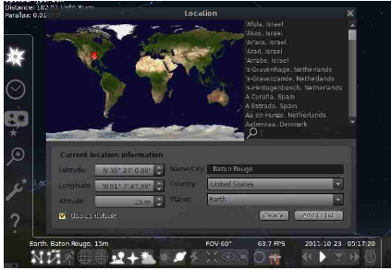

The default location is Paris, France. Go to the “Location window” icon to choose your city from a dropdown list (or input latitude and longitude). Next, go to the “Date/time window” to set your local time. By using up/down arrow controls you can see what the sky will look like at any future or past time (for example, what can I see if I go out tonight at 10:00 PM?).

Below is a screenshot of a night time view. I have added an azimuthal grid and constellation connectors. If you have a telescope with an equatorial mount, you can also display an equatorial grid. Clicking on any object will display key information (apparent magnitude, hour angle and declination, and azimuthal information updated for passage of time). Using the “ocular” view, you can see any listed object as viewed by a telescope of approximately 80x magnification.

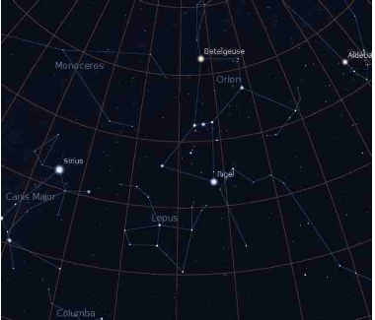

The default system includes 600,000 stars along with a full Messier catalog of Nebulae. The constellations of 10 different cultures are included. Various upgrade modules, plug-ins, and scripts exist (for example, you can expand to view over 200 million stars). Depending upon your needs, you can change the projected view of the sky – stereoscopic, fish-eye, cylindrical, etc. There is a text-entry search window quickly locate objects.

Download a free copy at stellarium.org (Linux users, find with your package manager). Smartphone versions are available for iOS (Android users, use Google Sky instead).

